**DAILY ONLINE ACTIVITIES SUMMARY**

|  |  |  |  |  |  |  |
| --- | --- | --- | --- | --- | --- | --- |
| **Date:** | | | **01/06/2020** | **Name:** | **JASLINE SHARON TAURO** | |
| **Sem & Sec** | | | **4th sem, A Section** | **USN:** | **4AL18CS029** | |
| **Online Test Summary** | | | | | | |
| **Subject** | **COMPLEX ANALYSIS, PROBABILITY AND STATISTICAL METHODS** | | | | | |
| **Max. Marks** | **30** | | | **Score** | **27** | |
| **Certification Course Summary** | | | | | | |
| **Course** | | | **Trailhead Basics** | | | |
| **Certificate Provider** | | **SALES FORCE** | | **Duration:** | | **3 HRS** |
| **Coding Challenges** | | | | | | |
| **Problem Statement:**   1. Given an array arr [] of size N and an integer K. The task is to find the count of subarrays such that each subarray has exactly K distinct elements. 2. Given an array of positive integers. Write a C Program to find the leaders in the array. | | | | | | |
| **Status: DONE** | | | | | | |
| **Uploaded the report in GitHub** | | | | **YES** | | |
| **If yes Repository name** | | | | [**https://github.com/jaslinesharontauro/C_Prgms**](https://github.com/jaslinesharontauro/C_Prgms) | | |
| **Uploaded the report in slack** | | | | **YES** | | |

**Online Test Details: (Attach the snapshot and briefly write the report for the same)**

**Certification Course Details: (Attach the snapshot and briefly write the report for the same)**

**Coding Challenges Details: (Attach the snapshot and briefly write the report for the same)**

**1.ONLINE TEST DETAILS:**

**Today we had assessment of the subject COMPLEX ANALYSIS, PROBABILITY AND STATISTICAL METHODS. The assessment was conducted on Fifth module of this subject. The questions were MCQ type. The test was comprised of 10 questions of ONE mark each, out of which I scored 9. And 10 questions of 2 marks each. Out of which I scored 18**

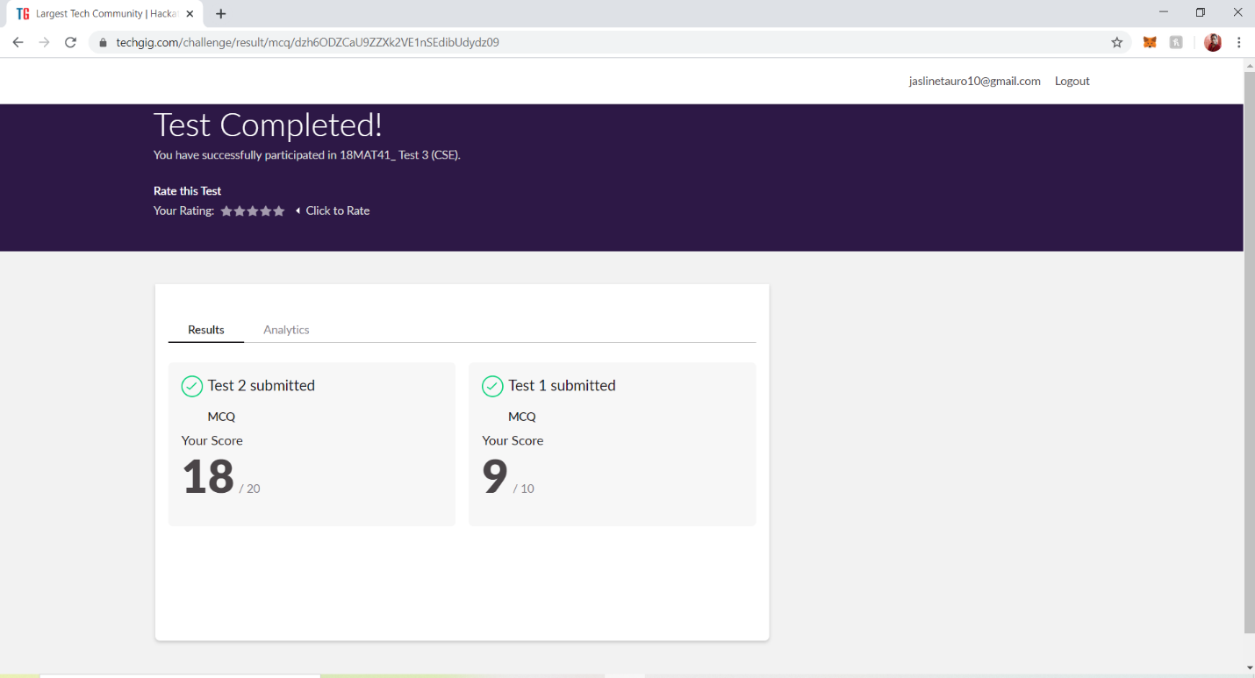**2.CERTIFICATION COURSE DETAILS**

**Today I have done the Course named Trailhead Basics by Sales Force. Today I have learnt basics of how to customize fields the salesforce using trails and trailhead playground.**

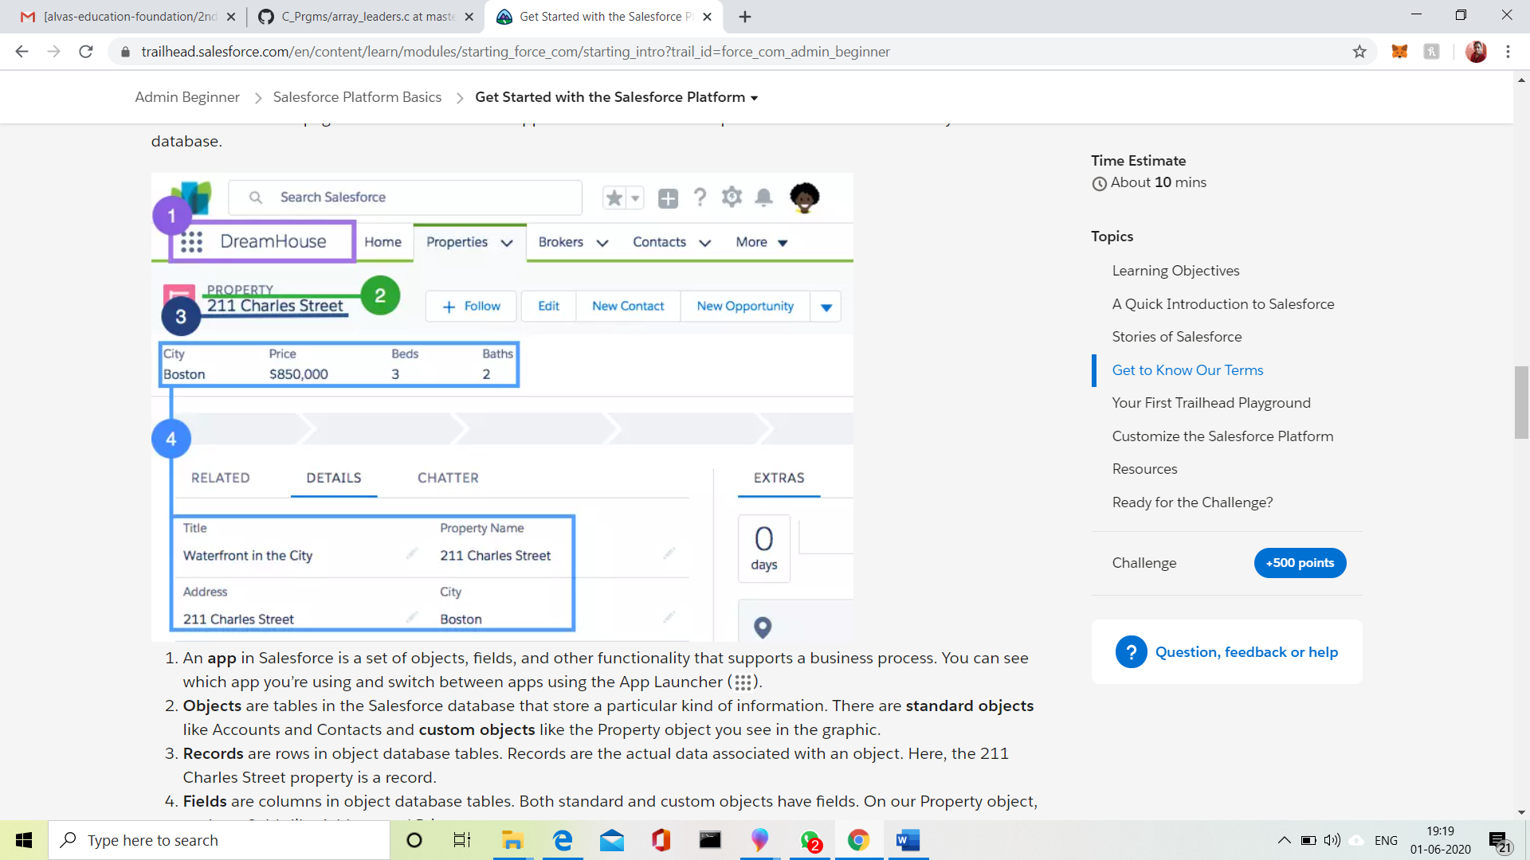

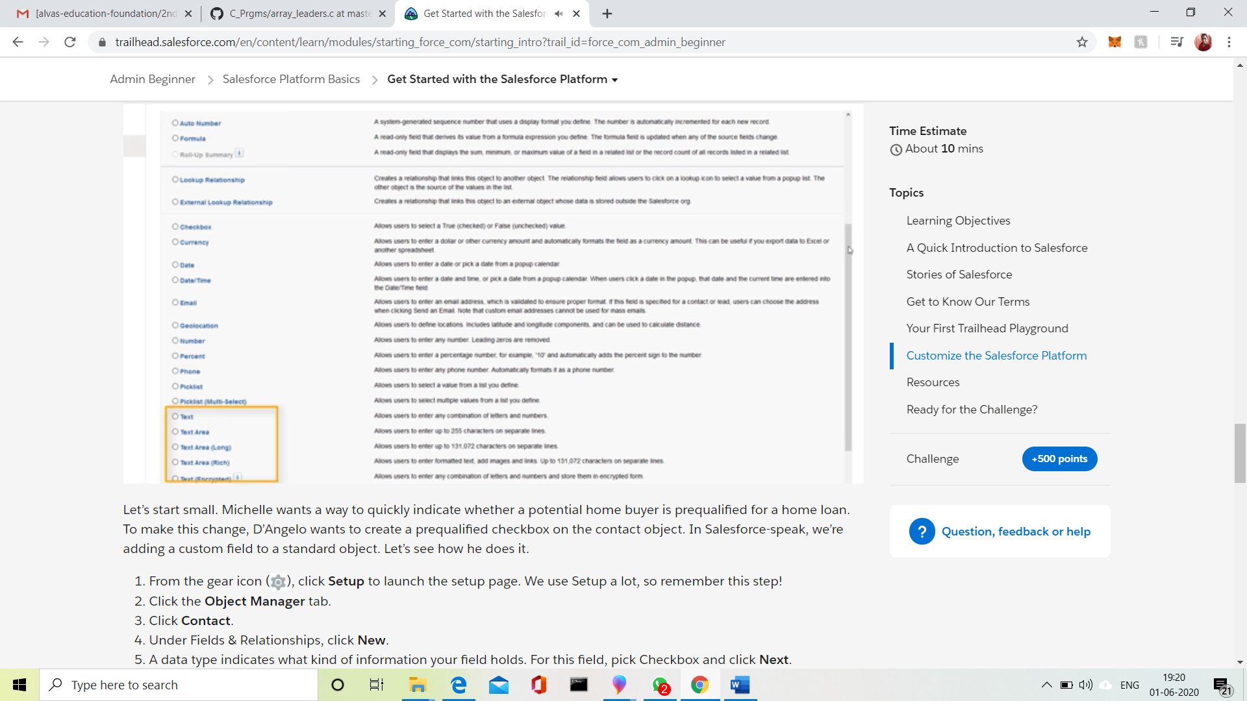

**3.CODING CHALLENGES DETAILS:**

**Problem statement 1:**

## Given an array arr [] of size N and an integer K. The task is to find the count of subarrays such that each subarray has exactly K distinct elements.

## Examples: Input: arr[] = {2, 1, 2, 1, 6}, K = 2 Output: 7 {2, 1}, {1, 2}, {2, 1}, {1, 6}, {2, 1, 2}, {1, 2, 1} and {2, 1, 2, 1} are the only valid subarrays

## 

Problem Statement 2:

Given an array of positive integers. Write a C Program to find the leaders in the array.

**Note:** An element of array is leader if it is greater than or equal to all the elements to its right side. Also, the rightmost element is always a leader.

**Input:**  
The first line of input contains an integer T denoting the number of test cases. The description of T test cases follows.  
The first line of each test case contains a single integer N denoting the size of array.  
The second line contains N space-separated integers A1, A2, ..., AN denoting the elements of the array.

**Output:**  
Print all the leaders.

**Constraints:**  
1 <= T <= 100  
1 <= N <= 107  
0 <= Ai <= 107

**Example:**

**Input:**  
3  
6  
16 17 4 3 5 2  
5  
1 2 3 4 0  
5  
7 4 5 7 3

**Output:**  
17 5 2  
4 0  
7 7 3  
**Explanation:  
Testcase 3:** All elements on the right of 7 (at index 0) are smaller than or equal to 7. Also, all the elements of right side of 7 (at index 3) are smaller than 7. And, the last element 3 is itself a leader since no elements are on its right.

